 

# DESIGN AND FABRICATION OF PORTABLE SALT WATER TO PURE WATER CONVERSATION

**A PROJECT REPORT**

***Submitted by***

HARIHANRA SUDHAN. M (927622BME026)

**HEMANTH KUMAR. S (927622BME027)**

**JAGADEEPAN. S (927622BME028)**

***in partial fulfillment for the award of the degree***

***of***

**BACHELOR OF ENGINEERING**

**IN**

# MECHANICAL ENGINEERING

**M.KUMARASAMY COLLEGE OF ENGINEERING, KARUR**

**ANNA UNIVERSITY: CHENNAI 600 025**

# NOV 2023

 

# DESIGN AND FABRICATION OF SALT WATER TO PURE WATER CONVERSATION

**A PROJECT REPORT**

***Submitted by***

**HARIHARA SUDHAN. M (92762BME026)**

**HEMANTH KUMAR. S (927622BME027)**

**JAGADEEPAN. S (927622BME028)**

***in partial fulfillment for the award of the degree***

***of***

**BACHELOR OF ENGINEERING**

***in***

**MECHANICAL ENGINEERING**

# M.KUMARASAMY COLLEGE OF ENGINEERING, KARUR

**ANNA UNIVERSITY: CHENNAI 600 025**

# NOV 2023

# BONAFIDE CERTIFICATE

Certified that this project report **“DESIGN AND FABRICATION OF PORTABLE SALT WATER TO PURE WATER”**is the bonafide work of **“HARIHARA SUDHAN. M (927622BME026), HEMANTH KUMAR. S (927622BME027), JAGADEEPAN. S (927622BME028)”** who carried out the project work during the academic year 2023 – 2024 under my supervision. Certified further, that to the best of my knowledge the work reported herein does not form part of any other project report or dissertation on the basis of which a degree or award was conferred on an earlier occasion on this or any other candidate.

|  |  |
| --- | --- |
| **SIGNATURE** | **SIGNATURE** |
|  |  |
| Dr. M. MOHAN PRASAD M.E., MBA., Ph.D. | Dr. R. KAMALAKANNAN, PH. D. |
| **HEAD OF THE DEPARTMENT** | **SUPERVISOR** |
| Department of Mechanical  Engineering, | Department of Mechanical Engineering, |
| M. Kumarasamy College of  Engineering, | M. Kumarasamy College of Engineering, |
| Thalavapalayam, Karur-639113. | Thalavapalayam, Karur-639113. |

## This project report has been submitted for the end semester project viva voce Examination held on ________________

**INTERNAL EXAMINER EXTERNAL EXAMINER**

## **DECLARATION**

We affirm that the Project titled **“DESIGN AND FABRICATION OF PORTABLE SALT WATER TO PURE WATER ”** being submitted in partial fulfillment of for the award of Bachelor of Engineering in Mechanical Engineering, is the original work carried out by us. It has not formed the part of any other project or dissertation on the basis of which a degree or award was conferred on an earlier occasion on this or any other candidate.

## **Student name Signature**

**1.** HARIHARA SUDHAN. M __________________

## **2.** HEMANTH KUMAR. S ___________________

**3.** JAGADEEPAN. S ___________________

**Name and signature of the supervisor with date**

# ACKNOWLEDGEMENT

Our sincere thanks to Thiru. M. Kumarasamy, Chairman and Dr. K. Ramakrishnan, B.E, Secretary of M. Kumarasamy College of Engineering for providing extra ordinary infrastructure, which helped us to complete the project in time.

It is a great privilege for us to express our gratitude to our esteemed Principal Dr.B.S. Murugan M.E., Ph.D. for providing us right ambiance for carrying out the project work.

We would like to thank Dr.M. Mohan Prasad M.E, MBA., Ph.D, Head, Department of Mechanical Engineering, for their unwavering moral support throughout the evolution of the project

We offer our whole hearted thanks to our internal guide Dr. R. KAMALAKANNA., Ph.D., Professor, Department of Mechanical Engineering, for her/his constant encouragement, kind co-operation, valuable suggestions and support rendered in making our project a success.

We offer our whole hearted thanks to our project coordinator Dr. R. KAMALAKANNA., Ph.D., Department of Mechanical Engineering, for her/his constant encouragement, kind co-operation, valuable suggestions and support rendered in making our project a success.

We glad to thank all the Teaching and Non-Teaching Faculty Members of Department of Mechanical Engineering for extending a warm helping hand and valuable suggestions throughout the project.

Words are boundless to thank Our Parents and Friends for their constant encouragement to complete this project successfully.

# INSTITUTION VISION & MISSION

**Vision**

* To emerge as a leader among the top institutions in the field of technical education.

# Mission

* Produce smart technocrats with empirical knowledge who can surmount the global challenges.
* Create a diverse, fully-engaged, learner-centric campus environment to provide quality education to the students.
* Maintain mutually beneficial partnerships with our alumni, industry and professional associations.

# DEPARTMENT VISION, MISSION, PEO, PO & PSO

**Vision**

* To create globally recognized competent Mechanical engineers to work in multicultural environment.

# Mission

* To impart quality education in the field of mechanical engineering and to enhance their skills, to pursue careers or enter into higher education in their area of interest.
* To establish a learner-centric atmosphere along with state-of-the-art research facility.
* To make collaboration with industries, distinguished research institution and to become a centre of excellence

# PROGRAM EDUCATIONAL OBJECTIVES (PEOS)

The graduates of Mechanical Engineering will be able to

* PEO1: Graduates of the program will accommodate insightful information of engineering principles necessary for the applications of engineering.
* PEO2: Graduates of the program will acquire knowledge of recent trends in technology and solve problem in industry.
* PEO3: Graduates of the program will have practical experience and interpersonal skills to work both in local and international environments.
* PEO4: Graduates of the program will possess creative professionalism, understand their ethical responsibility and committed towards society.

# PROGRAM OUTCOMES

**The following are the Program Outcomes of Engineering Graduates: Engineering Graduates will be able to:**

1. **Engineering knowledge:** Apply the knowledge of mathematics, science, engineering fundamentals, and an engineering specialization to the solution of complex engineering problems.
2. **Problem analysis:** Identify, formulate, review research literature, and analyze complex engineering problems reaching substantiated conclusions using first principles of mathematics, natural sciences, and engineering sciences.
3. **Design/development of solutions:** Design solutions for complex engineering problems and design system components or processes that meet the specified needs with appropriate consideration for the public health and safety, and the cultural, societal, and environmental considerations.
4. **Conduct investigations of complex problems:** Use research-based knowledge and research methods including design of experiments, analysis and interpretation of data, and synthesis of the information to provide valid conclusions.
5. **Modern tool usage:** Create, select, and apply appropriate techniques, resources, and modern engineeringand IT tools including prediction and modeling to complex engineering activities with an understanding of the limitations.
6. **The engineer and society:** Apply reasoning informed by the contextual knowledge to assess societal, health, safety, legal and cultural issues and the consequent responsibilities relevant to the professional engineering practice.
7. **Environment and sustainability:** Understand the impact of the professional engineering solutions in societal and environmental contexts, and demonstrate the knowledge of, and need for sustainable development.
8. **Ethics:** Apply ethical principles and commit to professional ethics and responsibilities and norms of the engineering practice.
9. **Individual and team work:** Function effectively as an individual, and as a member or leader in diverse teams, and in multidisciplinary settings.
10. **Communication:** Communicate effectively on complex engineering activities with the engineering community and with society at large, such as, being able to comprehend and write effective reports and design documentation, make effective presentations, and give and receive clear instructions.
11. **Project management and finance:** Demonstrate knowledge and understanding of the engineering and management principles and apply these to one’s own work, as a member and leader in a team, to manage projects and in multidisciplinary environments.
12. **Life-long learning:** Recognize the need for, and have the preparation and ability to engage in independent and life-long learning in the broadest context of

Technological change.

**PROGRAM SPECIFIC OUTCOMES (PSOs)**

**The following are the Program Specific Outcomes of Engineering Graduates:**

The students will demonstrate the abilities

* 1. **Real world application:** To comprehend, analyze, design and develop innovative products and provide solutions for the real-life problems.
  2. **Multi-disciplinary areas:** To work collaboratively on multi-disciplinary areas and make quality projects.

**Research oriented innovative ideas and methods:** To adopt modern tools, mathematical, scientific and engineering fundamentals required to solve industrial and societal problems

|  |  |  |
| --- | --- | --- |
| **Course Outcomes** | At the end of this course, learners will be able to: | **Knowledge Level** |
| CO-1 | Identify the issues and challenges related to industry, society and environment. | Apply |
| CO-2 | Describe the identified problem and formulate the possible solutions | Apply |
| CO-3 | Design / Fabricate new experimental set up/devices to provide solutions for  the identified problems | Analyse |
| CO-4 | Prepare a detailed report describing the project outcome | Apply |
| CO-5 | Communicate outcome of the project and defend by making an effective oral presentation. | Apply |

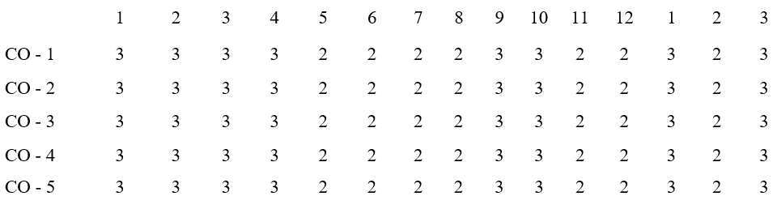

**MAPPING OF PO & PSO WITH THE PROJECT**

**OUTCOME**

**Program**

**Course**

**Outcomes**

**Program Outcomes**

**Specific**

**Outcomes**

# TABLE OF CONTENTS

|  |  |  |
| --- | --- | --- |
| **CHAPTER NO.** | **CONTENT** | **PAGE NO.** |
|  | ABSTRACT | 1 |
|  | SCOPE OF THIS PROJECT | 3 |
| 1. | INTRODUCTION | 5 |
| 2. | WORKING | 6 |
| 3. | MATERIALS | 7 |
| 3.1. | BATTERY | 7 |
| 3.2. | DC PUMP MOTOR | 8 |
| 3.3. | THERMOELECTRIC PELTIER | 8 |
| 3.4. | MINI AIR FAN FAN | 9 |
| 3.5. | COST ESTIMATION | 11 |
| 4. | DESIGN FOR DOMESTIC PURPOSE | 12 |
| 5. | WORKING PRINCIPLE | 13 |
| 5.1. | USES | 13 |
| 5.2. | ADVANTAGES | 13 |
| 5.3 | DISADVANTAGES | 14 |
| 6. | REFERENCE | 14 |

**ABSTRACT**

The increasing global demand for freshwater, coupled with the scarcity of traditional water sources, has necessitated the development of innovative and sustainable water purification technologies. This abstract introduces a portable desalination device designed to convert saline water into potable water, addressing the pressing issue of freshwater scarcity in remote and disaster-stricken regions.

The portable desalination unit employs advanced reverse osmosis technology, allowing it to efficiently remove salts and impurities from saline water, producing high-quality freshwater suitable for human consumption and agricultural use. The compact and lightweight design of the device facilitates easy deployment in emergency situations, ensuring access to clean water in areas where conventional water treatment infrastructure may be lacking.

Key features of the portable desalination unit include its energy-efficient operation, utilizing renewable energy sources such as solar power or hand-crank generators. This makes the device suitable for off-grid applications, providing a sustainable and environmentally friendly solution to water scarcity challenges. The modular construction of the system allows for scalability, enabling adaptation to varying water demands and resource availability.

The integration of smart monitoring and control systems ensures optimal performance and resource utilization, enhancing the longevity and efficiency of the portable desalination unit. Additionally, the use of durable and cost-effective materials contributes to the economic feasibility of the technology, making it accessible to a broad range of communities and disaster response organizations

In summary, the development of a portable saline water desalination system offers a promising solution to the global freshwater crisis, particularly in areas facing water scarcity and emergencies. The innovative design, coupled with sustainable energy options and smart technology integration, makes this portable system a versatile and efficient tool for providing reliable access to clean water in challenging environments.

# Scope of this project

**Water Scarcity Mitigation:** Desalination provides an alternative source of freshwater, especially in regions where access to clean drinking water is limited due to high salinity levels in natural water sources.

**Technological Advancements:** Ongoing research and advancements in desalination technologies aim to improve efficiency, reduce energy consumption, and lower costs associated with the process. Innovations such as membrane-based systems (reverse osmosis, nanofiltration), distillation techniques, and forward osmosis are continually evolving, expanding the scope for more sustainable and cost-effective solutions.

**Environmental Impacts:** While desalination offers a solution to freshwater scarcity, its widespread adoption requires addressing environmental concerns. The disposal of concentrated brine, energy consumption, and the impact on marine ecosystems remain areas of concern that need to be addressed through better technology and sustainable practices.

**Infrastructure Development:** Building desalination plants and associated infrastructure offers economic opportunities, job creation, and improved water security for communities, especially in arid and coastal regions.

**Integration with Renewable Energy:** Integrating desalination processes with renewable energy sources like solar and wind power can make the overall process more sustainable, reducing reliance on fossil fuels and minimizing environmental impact.

**Industrial and Agricultural Use:** Apart from providing drinking water, desalination can cater to the needs of various industries and agriculture, reducing the strain on existing freshwater sources and enabling sustainable growth in these sectors.

**Global Impact:** As water scarcity becomes a more pressing global issue due to climate change and increasing population demands, the scope for saltwater to pure water conversion becomes even more significant. Collaboration and knowledge-sharing among countries can enhance access to this technology and address water shortages on a larger scale.

**Challenges and Opportunities:** There are challenges associated with desalination, such as high initial costs, energy requirements, environmental impacts, and the need for continuous maintenance. Addressing these challenges presents opportunities for innovation and improvement in desalination.

1. **INTRODUCTION**

# CHAPTER-1

Water purification is the process of removing undesirable chemicals, biological contaminants, suspended solids and gases from contaminated water. The goal of this process is to produce water fit for a specific purpose. Distillation. Sea water is heated until it boils. The salt remains in the liquid, and the steam is pure water. The steam is cooled and condensed to make potable water. Water is purified by various processes, some of these are by reverse osmosis or by using UV filtered water purifiers, etc. The water which is not potable or fit for drinking is called raw water and is mostly from the sources like groundwater, rivers, and lakes. Potable water, also known as drinking water, comes from surface and ground sources and is treated to levels that that meet state and federal standards for consumption. Water from natural sources is treated for microorganisms, bacteria, toxic chemicals, viruses and fecal matter. Potable water is not pure water because it almost always contains dissolved. impurities. For water to be potable, it must have sufficiently low levels of dissolved salts. Identify the technology or methods to be employed for sea water desalination and cooling.Consider energy sources for the portable device, such as solar power, battery, or a combinationkey performance indicators (KPIs) to measure the efficiency and effectiveness of the device.

Metrics may include energy efficiency, water production rate, and cooling capacity. Portable water purification devices are self-contained, easily transported units used to purify water from untreated sources (such as rivers, lakes, and wells) for drinking purposes. Their main function is to eliminate pathogens, and often also of suspended solids and some unpalatable or toxic compounds. Distillation. Sea water is heated until it boils. The salt remains in the liquid, and the steam is pure water. The steam is cooled and condensed to make potable water.

1. **WORKING**

# CHAPTER-2

Portable water purification devices are self-contained, easily transported units used to purify water from untreated sources (such as rivers, lakes, and wells) for drinking purposes. Their main function is to eliminate pathogens, and often also of suspended solids and some unpalatable or toxic compounds. Distillation. Sea water is heated until it boils. The salt remains in the liquid, and the steam is pure water. The steam is cooled and condensed to make potable water. Water is purified by various processes, some of these are by reverse osmosis or by using UV filtered water purifiers, etc. The water which is not potable or fit for drinking is called raw water and is mostly from the sources like groundwater, rivers, and lakes. Potable water, also known as drinking water, comes from surface and ground sources and is treated to levels that that meet state and federal standards for consumption. Water from natural sources is treated for microorganisms, bacteria, toxic chemicals, viruses and fecal matter. Potable water is not pure water because it almost always contains dissolved. impurities. For water to be potable, it must have sufficiently low levels of dissolved salts.

# CHAPTER-3

1. **MATERIALS**

Materials Used:

* + Metal frame
  + Charcoal
  + Air supply fan
  + Copper pipe
  + Gear drive
  + Thermoelectric peltier
  + DC pump motor
  + Battery

**3.1. BATTERY**

A battery is a source of electric power for the portable salt water to sea water system.

A lithium battery with a capacity of 12V and 16000mAh (milliampere-hours) possesses a higher voltage compared to many common single-cell lithium-ion batteries, which usually operate around 3.7V. The 12V output indicates that this battery likely comprises multiple cells connected in series to achieve this voltage level. With a capacity of 16000mAh, this battery can deliver a steady current of 1 ampere (A) for 16 hours or 16 amperes for 1 hour before exhausting its charge. Keep in mind that the discharge rate affects the actual runtime, and different devices draw different currents.

**3.2. DC PUMP MOTOR:**

A dc pump motor is using to pump water from cooling tank one to cooling tank two.

A 3V DC pump motor is a specific type of motor designed to operate at a low voltage of 3 volts and is specifically engineered for pumping applications. These pumps are commonly used in various situations where a low-power, direct current motor is needed to create fluid flow. Here are some typical uses:

**Water Circulation:** These pumps can be used in small-scale water circulation systems, like in tabletop fountains, miniature irrigation systems, or hydroponic setups.

**Liquid Transfer:** They're employed in applications where liquids need to be transferred from one place to another, such as in small liquid dispensers, medical devices, or portable fuel transfer systems.

**Cooling Systems:** 3V DC pump motors can be utilized in small cooling systems, like in electronic devices or experimental setups requiring liquid cooling.

**Air Pumps:** In some cases, these pumps can also be adapted for air-related applications, like in small air pumps used for inflatable devices or certain aeration systems.

**3.3. THERMOELECTRIC PELTIER:**

* 1. The "thermoelectric Peltier" likely refers to a thermoelectric cooler based on the Peltier effect, which is often called a Peltier device or a thermoelectric module.
  2. The Peltier effect, named after the physicist Jean Charles Athanase Peltier, describes the phenomenon where an electric current flowing through two dissimilar conductors or semiconductors causes a heat transfer across the junctions. When a current passes through the junctions, one side of the device absorbs heat, while the other side releases it. This effect is reversible, enabling the device to function as both a cooler and a heater, depending on the direction of the current flow.
  3. A thermoelectric Peltier device consists of multiple semiconductor junctions connected in series and sandwiched between ceramic plates. When a direct current is applied, it creates a temperature gradient across the device, causing one side to become cooler while the other side gets warmer.
  4. These devices are used in various applications, including cooling electronic components, thermal management in small enclosures, portable refrigerators, beverage coolers, and precise temperature control in scientific instruments.
  5. However, they have limitations in terms of the maximum temperature differential they can achieve and the amount of heat they can transfer compared to traditional compressor-based refrigeration systems. Additionally, they are generally less energy-efficient but have the advantage of being compact, solid-state (no moving parts), and capable of both heating and cooling functions.

**3.4. MINI AIR SUPPLY FAN:**

A 12V DC air supply fan refers to a fan specifically designed to operate on a 12-volt direct current (DC) power source. These fans are commonly used in various applications where a low-voltage supply is available or required, such as in automotive, marine, recreational vehicles (RVs), electronics, or off-grid setups where 12V DC power sources are prevalent. Here are some key points about these fans:

**Voltage Requirement:** They are designed to work efficiently and safely with a 12V DC power supply, which can be obtained from batteries, solar panels with a 12V output, or other DC power sources.

**Air Circulation:** These fans circulate air within a space or help in directing airflow in a particular direction, aiding in ventilation, cooling, or heat dissipation.

**Variety:** They come in various sizes, designs, and airflow capacities to suit different requirements. Some may have additional features like speed control, PWM (Pulse Width Modulation) support, or temperature sensors.

**Applications:** Common applications include cooling electronic components, providing ventilation in confined spaces, improving airflow in vehicles or enclosures, and aiding in heat dissipation in various systems.

**Installation:** They are relatively easy to install and can be mounted on walls, ceilings, or within enclosures, depending on the specific design and intended purpose.

**Efficiency:** These fans are generally designed for energy efficiency, especially when used in systems powered by batteries or renewable energy sources like solar panels.

**Noise Level:** Depending on the fan's design and quality, they can operate quietly or with moderate noise levels, and some fans prioritize low-noise operation for applications where noise is a concern.

* 1. **3.5. COST ESTIMATION:**

|  |  |  |  |
| --- | --- | --- | --- |
| **Components** | **Quantity** | **Cost (Rs)** | **Total**  **(Rs)** |
| Thermoelectric peltier | 1*400 | 400 | 400 |
| Frame | 1*800 | 800 | 800 |
| DC pump motor | 2*100 | 200 | 200 |
| Battery(12v) | 1*500 | 500 | 500 |
| Air supply fan | 2*100 | 200 | 200 |
| Charcoal | 1kg | 150 | 150 |
| Copper pipe | 6 feet | 500 | 500 |
| Charging unit |  | 500 | 500 |
| TOTAL COST | | | 3250 |

1. **DESIGN**

# CHAPTER-4

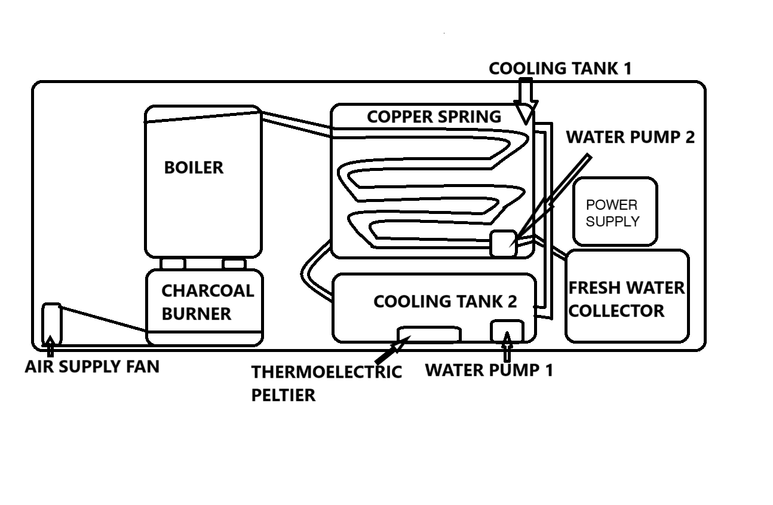

**Design for domestic p:urpose**

1. **WORKING PRINCIPLE:**

**CHAPTER-5**

Seawater or other water is pouring into the container. The container capacity of 1.5 l of 1l of water is pouring. Using charcoal to burn and heat to the container. Initially, it gets heated slowly after it gets some certain temperature it gets boiled water. The unwanted and germ contents are settle at the bottom. Due to vapour pressure, it flows through the copper spring to cool the water.

The water get slow cooling while pouring the normal water it gets more cooling and drinkable water. Using pipe through get a normal water as well as drinkable water.

**5.1. USES:**

1. Emergency Situations: In disaster-struck areas.
2. Marine Applications: On boats, ships, or during ocean expeditions where freshwater is limited or unavailable.
3. Military and Field Operations.
4. Outdoor Activities: For hikers, campers, or adventurers exploring remote areas.
5. Individual Preparedness: Compact portable desalination devices.
   1. **ADVANTAGES:**
      * Budget friendly
      * Bacteries can also killed in water during this process
      * Simple process
      * Easy to maintain
      * No skilled person are required
   2. **DISADVANTAGES:**

* Old process.
* Time consuming.
* Can’t covert all salt water into pure water.
* During rainy its tough to burn coal.

**CHAPTER-6**

1. **REFERENCE:**
2. Sustainable freshwater production using passive membrane distillation and waste heat recovery from portable generator sets.

**M Morciano, M Fasano, L Bergamasco, A Albiero… - Applied Energy, 2020 – Elsevier.**

1. Bringing near field communication under water: short range data exchange in fresh and salt water..

**A Pozzebon - 2015 International EURASIP Workshop on RFID …, 2015 - ieeexplore.ieee.org**

1. Real-time detection of chlorpyrifos at part per trillion levels in ground, surface and drinking water samples by a portable surface plasmon resonance immunosensor.

**E Mauriz, A Calle, LM Lechuga, J Quintana… - Analytica Chimica …, 2006 - Elsevier**

1. Direct seawater desalination by ion concentration polarization.

**SJ Kim, SH Ko, KH Kang, J Han - Nature nanotechnology, 2010 - nature.com**

1. Energy consumption for the desalination of salt water using polyelectrolyte hydrogels as the separation agent.

**L Arens, JB Albrecht, J Höpfner… - Macromolecular …, 2017 - Wiley Online Library**

1. Resistance to fresh and salt water in intertidal mites (Acari: Oribatida): implications for ecology and hydrochorous dispersal.

**T Pfingstl - Experimental and Applied Acarology, 2013 - Springer**

1. A study of hydrogen generation by reaction of an activated Mg–CoCl2 (magnesium–cobalt chloride) composite with pure water for portable applications.

**Q Sun, M Zou, X Guo, R Yang, H Huang, P Huang… - Energy, 2015 - Elsevier**

1. Salt water intrusion in the United States.

**BD Newport - 1977 - books.google.com**

1. Design and fabrication of a portable and hybrid solar-powered membrane distillation system.

**A Chafidz, ED Kerme, I Wazeer, Y Khalid… - Journal of cleaner …, 2016 - Elsevier**

1. Fresh water from sea water by solar distillation.

**M Telkes - Industrial & Engineering Chemistry, 1953 - ACS Publications**

1. An integrated, solar-driven membrane distillation system for water purification and energy generation.

**Q Li, LJ Beier, J Tan, C Brown, B Lian, W Zhong… - Applied Energy, 2019 - Elsevier**

1. Portable and integrated solar-driven desalination system using membrane distillation for arid remote areas in Saudi Arabia.

**A Chafidz, S Al-Zahrani, MN Al-Otaibi, CF Hoong… - Desalination, 2014 - Elsevier**

1. Potentials of Solar Distillation Technologies for Provision of Portable Water for Makurdi Metropolis–A Review.

**AO Edeoja, A Kuhe, A Kwaghger - International Journal of Engineering …, 2017 - hal.science**

1. Water desalination technologies utilizing conventional and renewable energy sources.

**M Shatat, SB Riffat - International Journal of Low-Carbon …, 2014 - academic.oup.com**

1. Homemade solar desalination system for Omani families.

**MT Chaichan, HA Kazem, KI Abaas… - International Journal of …, 2016 - researchgate.net**